**SYNTAX**

1. Write a program for fing a straight line through a set of points (xi , y i ), i = 1,....,n. The straight line equaon is y = mx + c and the values of m and c are given y All summaons are from 1 to n.
2. The daily maximum temperatures recorded in 10 cies during the month of January (for all 31 days) have been tabulated as follows:

Write a program to read the table elements into a two-dimensional array temperature , and to find the city and day corresponding to (a) the highest temperature and (b) the lowest temperature.

1. An elecon is contested by 5 candidates. The candidates are numbered 1 to 5 and the vong is done by marking the candidate number on the ballot paper. Write a program to read the ballots and count the votes cast for each candidate using an array variable count . In case, a number read is outside the range 1 to 5, the ballot should be considered as a ‘spoilt ballot’ and the program should also count the number of spoilt ballots.
2. The following set of numbers is popularly known as Pascal’s triangle. If we denote rows by i and columns by j, then any element (except the boundary elements) in the triangle is given by p ij = p i–1 , j–1 + p i–1 ,

1. The annual examinaon results of 100 students are tabulated as follows:

Write a program to read the data and determine the following: (a) Total marks obtained by each student. (b) The highest marks in each subject and the Roll No. of the student who secured it. (c) The student who obtained the highest total marks.

1. Given are two one-dimensional arrays A and B which are sorted in ascending order. Write a program to merge them into a single sorted array C that contains every item from arrays A and B, in ascending order.
2. Two matrices that have the same number of rows and columns can be mulplied to produce a

third matrix. Consider the following two matrices.

1. The product of A and B is a third matrix C of size n¥ n where each element of C is given by the following equaon. Write a program that will read the values of elements of A and B and produce the product matrix C.
2. Write a program that fills a five-by-five matrix as follows: • Upper le triangle with +1s • Lower right triangle with –1s • Right to le diagonal with zeros Display the contents of the matrix using not more than two prin statements.
3. develop a program to implement the binary search algorithm. This technique compares the search key value with the value of the element that is midway in a “sorted” list. Then; (a) If they match, the search is over.

b)If the search key value is less than the middle value, then the first half of the list contains the key value.

(c) If the search key value is greater than the middle value, then the second half contains the key value. Repeat this “divide-and-conquer” strategy unl we have a match. If the list is reduced to one nonmatching element, then the list does not contain the key value. Use the sorted list created in Exercise 8.9 or use any other sorted list.

1. Write a program that will compute the length of a given character string.
2. Write a program that will count the number occurrences of a specified character in a given line of text. Test your program.
3. Write a program to read a matrix of size m ¥ n and print its transpose.
4. Every book published by internaonal publishers should carry an Internaonal Standard Book Number (ISBN). It is a 10 character 4 part number as shown below. 0-07-041183-2 The first part denotes the region, the second represents publisher, the third idenfies the book and the fourth is the check digit. The check digit is computed as follows: Sum = (1 × first digit) + (2 × second digit) + (3 × third digit) + - - - - + (9 × ninth digit). Check digit is the remainder when sum is divided by 11. Write a program that reads a given ISBN number and checks whether it represents a valid ISBN.
5. Write a program to read two matrices A and B and print the following:

(a) A + B; and

(b) A – B.

1. Write a program for fing a straight line through a set of points (xi , y i ), i = 1,....,n. The straight line equaon is y = mx + c and the values of m and c are given y All summaons are from 1 to n.

Ans:

#include <stdio.h>

int main() {

int n;

printf("Enter the number of points: ");

scanf("%d", &n);

double x[n], y[n];

printf("Enter the coordinates of the points (xi yi):\n");

for (int i = 0; i < n; i++) {

scanf("%lf %lf", &x[i], &y[i]);

}

double sum_x = 0, sum_y = 0, sum_xy = 0, sum_x_squared = 0;

for (int i = 0; i < n; i++) {

sum_x += x[i];

sum_y += y[i];

sum_xy += x[i] * y[i];

sum_x_squared += x[i] * x[i];

}

double m = (n * sum_xy - sum_x * sum_y) / (n * sum_x_squared - sum_x * sum_x);

double c = (sum_y - m * sum_x) / n;

printf("Equation of the straight line: y = %.4lf * x + %.4lf\n", m, c);

return 0;

}

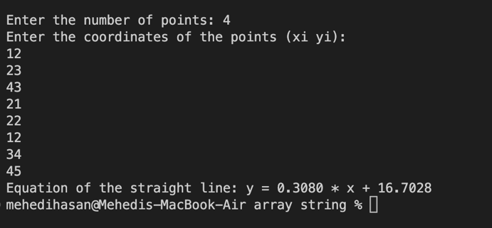

2. The daily maximum temperatures recorded in 10 cies during the month of January (for all 31 days) have been tabulated as follows:

Write a program to read the table elements into a two-dimensional array temperature , and to find the city and day corresponding to (a) the highest temperature and (b) the lowest temperature.

#include <stdio.h>

int main() {

int cities = 1;

int days = 5;

int temperature[cities][days];

printf("Enter the daily maximum temperatures for each city:\n");

for (int i = 0; i < cities; i++) {

printf("City %d:\n", i + 1);

for (int j = 0; j < days; j++) {

printf("Day %d: ", j + 1);

scanf("%d", &temperature[i][j]);

}

}

int highestTemp = temperature[0][0];

int lowestTemp = temperature[0][0];

int highestCity, highestDay, lowestCity, lowestDay;

for (int i = 0; i < cities; i++) {

for (int j = 0; j < days; j++) {

if (temperature[i][j] > highestTemp) {

highestTemp = temperature[i][j];

highestCity = i;

highestDay = j;

}

if (temperature[i][j] < lowestTemp) {

lowestTemp = temperature[i][j];

lowestCity = i;

lowestDay = j;

}

}

}

printf("Highest Temperature: %d°C in City %d on Day %d\n", highestTemp, highestCity + 1, highestDay + 1);

printf("Lowest Temperature: %d°C in City %d on Day %d\n", lowestTemp, lowestCity + 1, lowestDay + 1);

return 0;

}

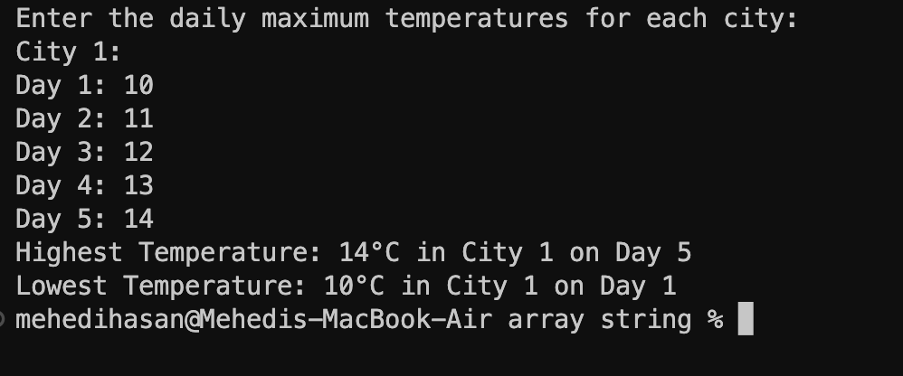

1. An elecon is contested by 5 candidates. The candidates are numbered 1 to 5 and the vong is done by marking the candidate number on the ballot paper. Write a program to read the ballots and count the votes cast for each candidate using an array variable count . In case, a number read is outside the range 1 to 5, the ballot should be considered as a ‘spoilt ballot’ and the program should also count the number of spoilt ballots.

#include <stdio.h>

int main() {

int candidates = 5;

int ballots;

int count[candidates + 1];

int spoiltBallots = 0;

for (int i = 0; i <= candidates; i++) {

count[i] = 0;

}

printf("Enter the number of ballots: ");

scanf("%d", &ballots);

for (int i = 0; i < ballots; i++) {

int vote;

printf("Enter vote for ballot %d: ", i + 1);

scanf("%d", &vote);

if (vote >= 1 && vote <= candidates) {

count[vote]++;

} else {

spoiltBallots++;

}

}

printf("\nVote Count:\n");

for (int i = 1; i <= candidates; i++) {

printf("Candidate %d: %d votes\n", i, count[i]);

}

printf("Spoilt Ballots: %d\n", spoiltBallots);

return 0;

}



4. The following set of numbers is popularly known as Pascal’s triangle. If we denote rows by i and columns by j, then any element (except the boundary elements) in the triangle is given by p ij = p

i–1 , j–1 + p i–1 ,

#include <stdio.h>

int main()

{

int i, j, pascal[11][11] = {0}; prin("\t\t\t\t\t Pascal Triangle\n");

for (i = 1; i <= 10; i++)

{

for (j = 1; j <= 10; j++)

{

if (i == j)

{

pascal[i][j] = 1; break; }

if (j == 1)

{

pascal[i][j] = 1;

}

else

{

pascal[i][j] = pascal[i - 1][j - 1] + pascal[i - 1][j];

}

}

}

for (i = 1; i <= 10; i++)

{

for (j = 1; j <= 10; j++)

{

if (i + 1 == j)

break;

else

prin("%d\t", pascal[i][j]);

}

prin("\n");

}

return 0;

}

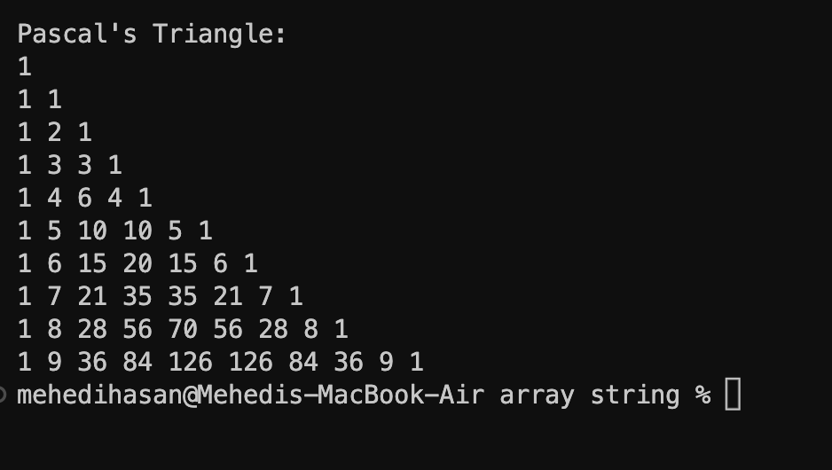

5. The annual examinaon results of 100 students are tabulated as follows:

Write a program to read the data and determine the following: (a) Total marks obtained by each student. (b) The highest marks in each subject and the Roll No. of the student who secured it. (c) The student who obtained the highest total marks.

#include <stdio.h>

int main()

{

int i, j, sum = 0;

int max_total = 0, max_sub[3] = {0};

int marks[100][4] = {0}, highest[100] = {0};

printf("Enter Marks of 100 Students: \n");

for (i = 0; i < 100

; i++)

{

marks[i][0] = i + 1;

for (j = 1; j < 4; j++)

{

scanf("%d", &marks[i][j]);

}

}

printf("Roll Subject1 Subject2 Subject3 Total Marks\n");

for (i = 0; i < 100; i++)

{

sum = 0;

for (j = 1; j < 4; j++)

{

sum += marks[i][j];

}

if (max_total < sum)

max_total = sum;

highest[i] = sum;

printf("%4d %8d %8d %8d %10d\n", marks[i][0], marks[i][1], marks[i][2], marks[i][3], highest[i]);

}

{

if (max_sub[0] < marks[i][1])

max_sub[0] = marks[i][1];

if (max_sub[1] < marks[i][2])

max_sub[1] = marks[i][2];

if (max_sub[2] < marks[i][3])

max_sub[2] = marks[i][3];

}

for (i = 0; i < 3; i++)

{

printf("\n----------------------------------------------------------------\n");

printf("\tHighest on Subject%d:\nMarks: %d\nRolls: ", i + 1, max_sub[i]);

for (j = 0; j < 100; j++)

{

if (marks[j][i + 1] == max_sub[i])

printf("%d\t", marks[j][0]);

}

printf("\n");

}

return 0;

}

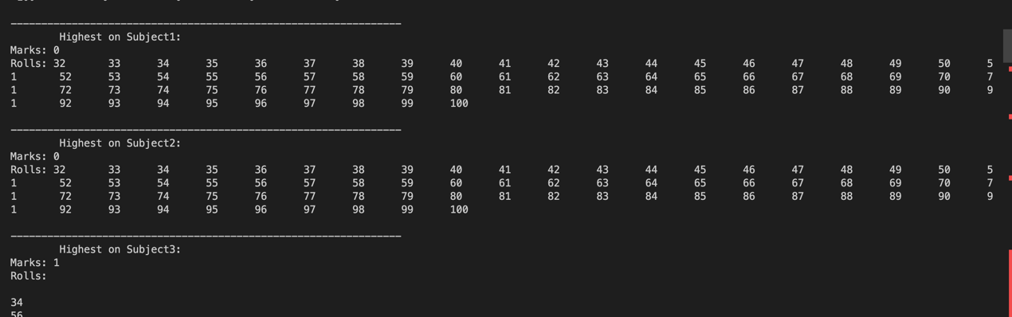

6. Given are two one-dimensional arrays A and B which are sorted in ascending order. Write a

program to merge them into a single sorted array C that contains every item from arrays A and B,

in ascending order.

#include <stdio.h>

int main()

{ int i;

int matrixA[9] = {1, 2, 3, 4, 5, 6, 7, 8, 9};

int matrixB[9] = {11, 12, 13, 14, 15, 16, 17, 18, 19};

int lengthA = sizeof(matrixA) / sizeof(int); int lengthB = sizeof(matrixB) / sizeof(int); int lengthC = lengthA + lengthB; int matrixC[lengthC];

for (i = 0; i < lengthA; i++)

{

matrixC[i] = matrixA[i];

}

for (i = 0; i < lengthB; i++)

{

matrixC[i + lengthA] = matrixB[i];

}

for (i = 0; i < lengthC; i++)

{

printf("%d\t", matrixC[i]);

}

return 0;

}



7. Two matrices that have the same number of rows and columns can be mulplied to produce a

third matrix. Consider the following two matrices.

#include <stdio.h>

#define ROWS 3

#define COLS 3

void multiplyMatrices(int A[][COLS], int B[][COLS], int C[][COLS]) {

for (int i = 0; i < ROWS; i++) {

for (int j = 0; j < COLS; j++) {

C[i][j] = 0;

for (int k = 0; k < COLS; k++) {

C[i][j] += A[i][k] * B[k][j];

}

}

}

}

void printMatrix(int matrix[][COLS]) {

for (int i = 0; i < ROWS; i++) {

for (int j = 0; j < COLS; j++) {

printf("%d ", matrix[i][j]);

}

printf("\n");

}

}

int main() {

int matrixA[ROWS][COLS] = {

{1, 2, 3},

{4, 5, 6},

{7, 8, 9}

};

int matrixB[ROWS][COLS] = {

{9, 8, 7},

{6, 5, 4},

{3, 2, 1}

};

int resultMatrix[ROWS][COLS];

multiplyMatrices(matrixA, matrixB, resultMatrix);

printf("Matrix A:\n");

printMatrix(matrixA);

printf("\nMatrix B:\n");

printMatrix(matrixB);

printf("\nResult Matrix:\n");

printMatrix(resultMatrix);

return 0;

}

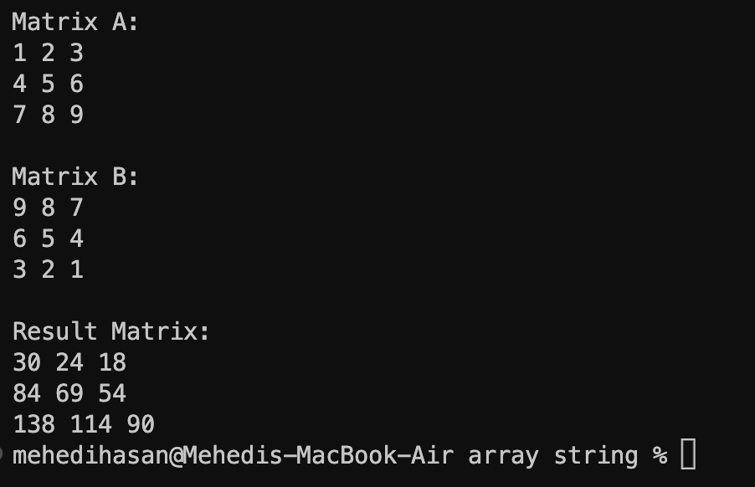

8. The product of A and B is a third matrix C of size n¥ n where each element of C is given by the following equaon. Write a program that will read the values of elements of A and B and produce the product matrix C.

#include <stdio.h>

int main()

{

int matrix[5][5];

int i, j;

for (i = 0; i < 5; i++)

{

for (j = 0; j < 5; j++)

{

if (j < 5 - i - 1) matrix[i][j] = 1; else if (j > 5 - i - 1) matrix[i][j] = -1;

else

matrix[i][j] = 0;

}

}

for (i = 0; i < 5; i++)

{

for (j = 0; j < 5; j++)

{

printf("%d ", matrix[i][j]);

}

printf("\n");

}

return 0;

}

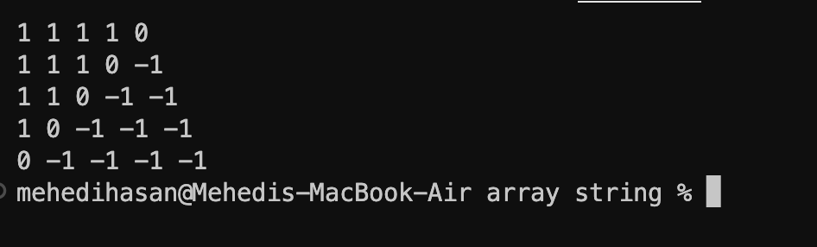

9. Write a program that fills a five-by-five matrix as follows: • Upper le triangle with +1s • Lower right triangle with –1s • Right to le diagonal with zeros Display the contents of the matrix using not more than two prin statements.

#include <stdio.h>

int main()

{

int elements[100], n, c, d, pos, temp;

printf("Enter the number of elements: ");

scanf("%d", &n);

printf("Enter %d integers:\n", n);

for (c = 0; c < n; c++)

{

scanf("%d", &elements[c]);

}

for (c = 0; c < n - 1; c++)

{

pos = c;

for (d = c + 1; d < n; d++)

{

if (elements[pos] > elements[d])

{

pos = d;

}

}

if (pos != c)

{

temp = elements[c];

elements[c] = elements[pos];

elements[pos] = temp;

}

}

printf("Sorted list in ascending order:\n");

for (c = 0; c < n; c++)

{

printf("%d\t", elements[c]);

}

return 0;

}

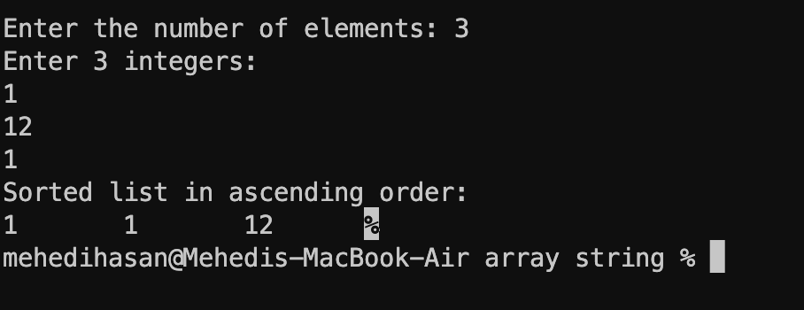

10. develop a program to implement the binary search algorithm. This technique compares the search key value with the value of the element that is midway in a “sorted” list. Then; (a) If they match, the search is over.

If the search key value is less than the middle value, then the first half of the list contains the key value.

If the search key value is greater than the middle value, then the second half contains the key value. Repeat this “divide-and-conquer” strategy unl we have a match. If the list is reduced to one nonmatching element, then the list does not contain the key value. Use the sorted list created in Exercise 8.9 or use any other sorted list.

#include <stdio.h>

int binarySearch(int arr[], int size, int key) {

int low = 0;

int high = size - 1;

while (low <= high) {

int mid = (low + high) / 2;

if (arr[mid] == key) {

return mid;

} else if (arr[mid] < key) {

low = mid + 1;

} else {

high = mid - 1;

}

}

return -1;

}

int main() {

int sortedList[] = {1, 3, 5, 7, 9, 11, 13, 15, 17, 19};

int size = sizeof(sortedList) / sizeof(sortedList[0]);

int key;

printf("Enter the key value to search for: ");

scanf("%d", &key);

int index = binarySearch(sortedList, size, key);

if (index != -1) {

printf("Key found at index %d\n", index);

} else {

printf("Key not found\n");

}

return 0;

}

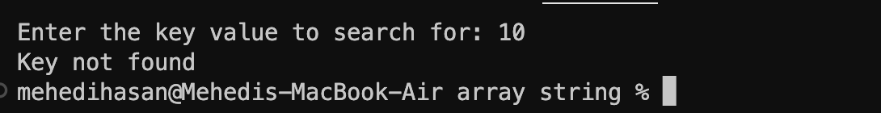

11.Write a program that will compute the length of a given character string.

#include <stdio.h>

int main()

{

int i = 0, size = 0, counter = 0;

char text[10000];

printf("Enter a Character Array: ");

scanf("%s", text);

while (text[size] != '\0')

{

size++;

}

for (i = 0; i < size; i++)

{

if (text[i] != ' ')

{

counter++;

}

}

printf("Total Number of Characters: %d\n", counter);

}

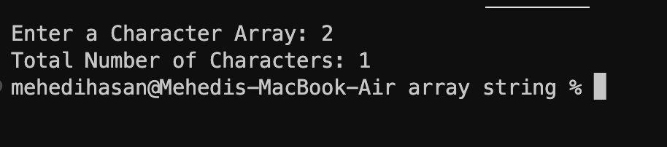

12. Write a program that will count the number occurrences of a specified character in a given line of text. Test your program.

#include <stdio.h>

int main()

{

int i, counter = 0;

char text[10000], key;

printf("Enter a Character Array: ");

scanf("%s", text);

getchar();

printf("Enter a Search Key Character: ");

scanf("%c", &key);

for (i = 0; text[i] != '\0'; i++)

{

if (text[i] == key)

{

counter++;

}

}

printf("Total Number of '%c' Characters: %d\n", key, counter);

return 0;

}

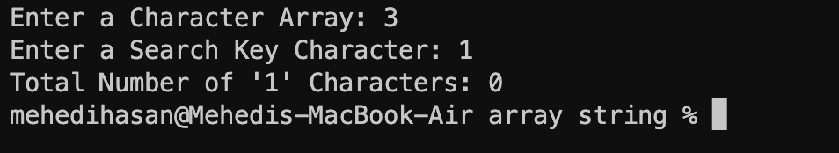

13. Write a program to read a matrix of size m ¥ n and print its transpose.

#include <stdio.h>

int main()

{

int i, j, row, col;

printf("Enter Row & Columns Size: ");

scanf("%d %d", &row, &col);

int matrix[row][col];

printf("Enter Matrix Elements:\n");

for (i = 0; i < row; i++)

{

for (j = 0; j < col; j++)

{

scanf("%d", &matrix[i][j]);

}

}

printf("Entered Matrix:\n");

for (i = 0; i < row; i++)

{

printf("\t|");

for (j = 0; j < col; j++)

{

printf("%4d", matrix[i][j]);

}

printf(" |\n");

}

printf("Matrix Transposed:\n");

for (i = 0; i < col; i++)

{

printf("\t|");

for (j = 0; j < row; j++)

{

printf("%4d", matrix[j][i]);

}

printf(" |\n");

}

return 0;

}

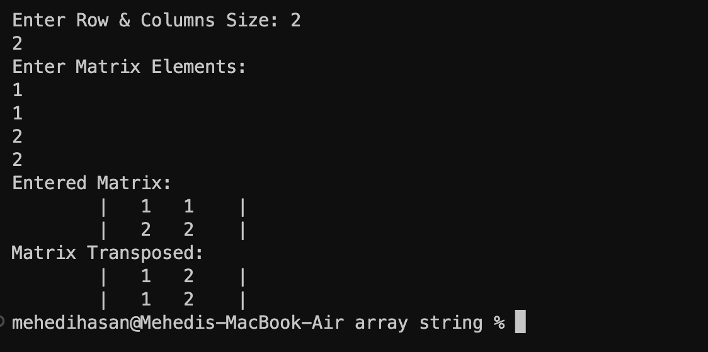

14. Every book published by internaonal publishers should carry an Internaonal Standard Book Number (ISBN). It is a 10 character 4 part number as shown below. 0-07-041183-2 The first part denotes the region, the second represents publisher, the third idenfies the book and the fourth is the check digit. The check digit is computed as follows: Sum = (1 × first digit) + (2 × second digit) + (3 × third digit) + - - - - + (9 × ninth digit). Check digit is the remainder when sum is divided by 11. Write a program that reads a given ISBN number and checks whether it represents a valid ISBN. #include <stdio.h>

int main()

{

int first, second, third, forth;

printf("Enter Book's ISBN Number: ");

scanf("%d-%d-%d-%d", &first, &second, &third, &forth);

printf("\n\t\tBook Informaon\n\t ------------------------------\n");

printf("Region Number: %d\n", first);

printf("Publisher Number: %d\n", second);

printf("Book Idenfier: %d\n", third);

printf("Checker Digit: %d\n", forth);

return 0;

}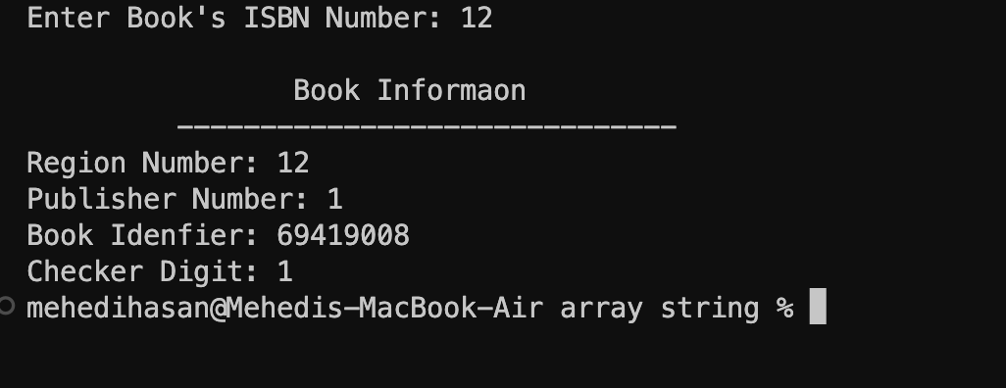

15. Write a program to read two matrices A and B and print the following:

1. A + B; and
2. A – B.

#include <stdio.h>

#define MAX_ROWS 10

#define MAX_COLS 10

int main() {

int matrixA[MAX_ROWS][MAX_COLS], matrixB[MAX_ROWS][MAX_COLS];

int resultSum[MAX_ROWS][MAX_COLS], resultDiff[MAX_ROWS][MAX_COLS];

int m, n;

printf("Enter the number of rows (m): ");

scanf("%d", &m);

printf("Enter the number of columns (n): ");

scanf("%d", &n);

printf("Enter the elements of matrix A:\n");

for (int i = 0; i < m; i++)

for (int j = 0; j < n; j++)

scanf("%d", &matrixA[i][j]);

printf("Enter the elements of matrix B:\n");

for (int i = 0; i < m; i++)

for (int j = 0; j < n; j++)

scanf("%d", &matrixB[i][j]);

for (int i = 0; i < m; i++)

for (int j = 0; j < n; j++)

resultSum[i][j] = matrixA[i][j] + matrixB[i][j];

for (int i = 0; i < m; i++)

for (int j = 0; j < n; j++)

resultDiff[i][j] = matrixA[i][j] - matrixB[i][j];

printf("\nMatrix A + B:\n");

for (int i = 0; i < m; i++) {

for (int j = 0; j < n; j++)

printf("%d ", resultSum[i][j]);

printf("\n");

}

printf("\nMatrix A - B:\n");

for (int i = 0; i < m; i++) {

for (int j = 0; j < n; j++)

printf("%d ", resultDiff[i][j]);

printf("\n");

}

return 0;

}

